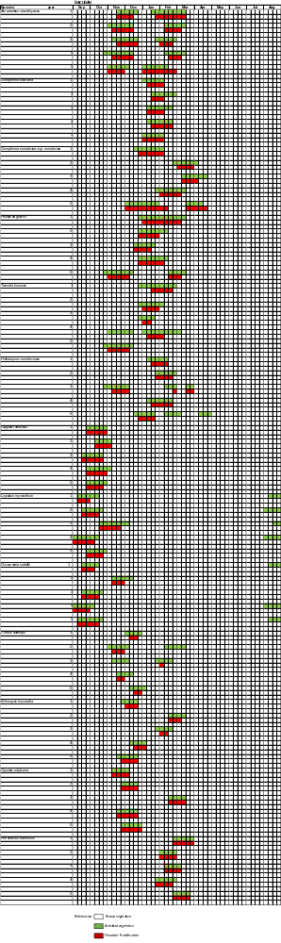
Figure S1. Pheno A.
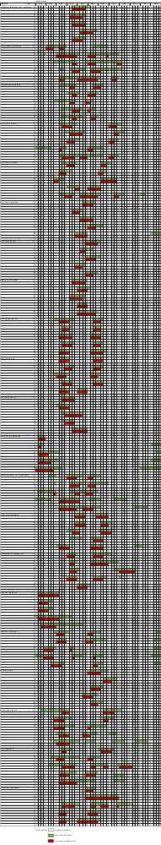
Figure S2. Pheno B.
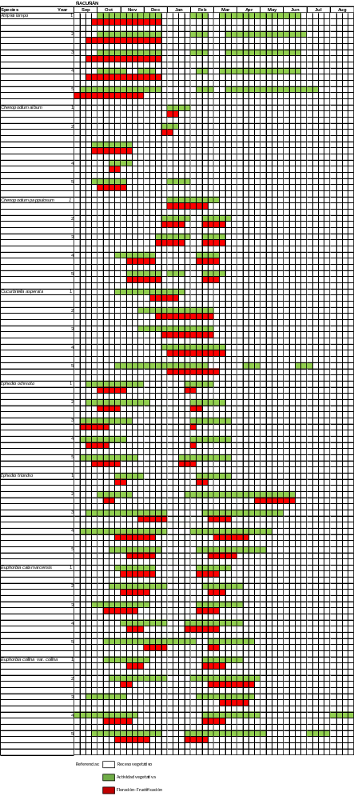
Figure S3. Pheno C.
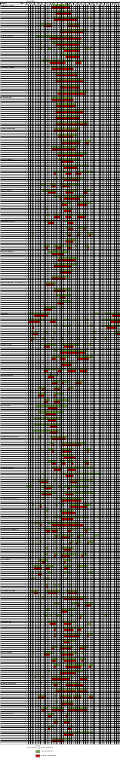
Figure S4. Pheno D.
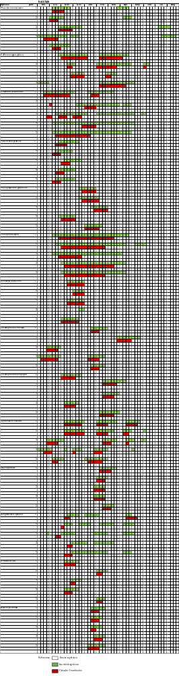
Figure S5. Pheno E.
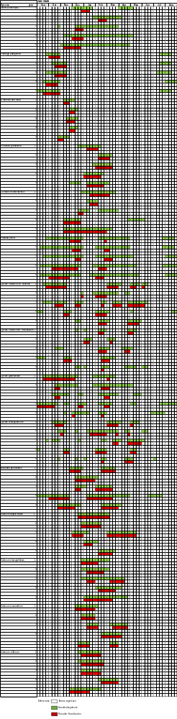
Figure S6. Pheno F.
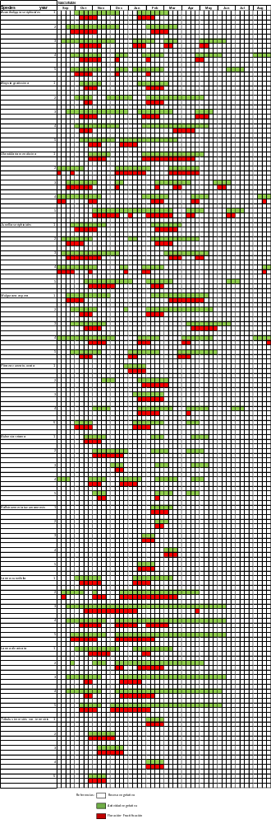
Figure S7. Pheno G.

