Supporting files for
Kinetic Study of Methane Hydrate Formation by a Small-Molecule Peptide (Glutathione) and Its Complex System
Xiaolong Zhu¹, Xiao Wu¹, Zhibo Jiang¹, Lei Yang^{1, 2, *} Yongchen Song¹
¹ Key Laboratory of Ocean Energy Utilization and Energy Conservation of Ministry of Education, Dalian University of Technology, Dalian, China
² Ningbo Institute of Dalian University of Technology, Dalian University of Technology, Ningbo, China
leiyang@dlut.edu.cn (Lei Yang)
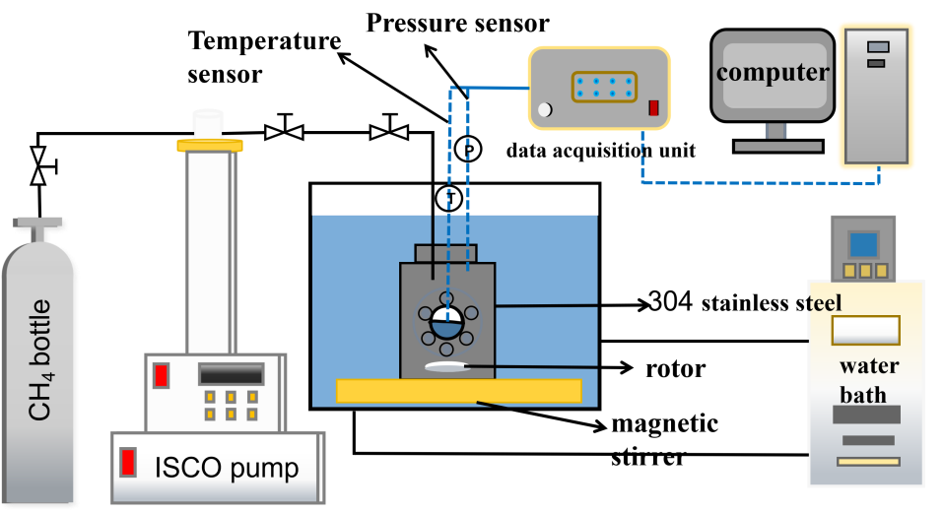
Figure S1. Schematic Diagram of Experimental Equipment.
Table 1. A part of experimental data for different conditions.
sample | induction time | standard deviation | gas storage capacity | standard deviation | standard methane gas absorption | standard deviation
Pure water | 242.7 | 85.95 | 2.65 | 1.08 | 0.0021 | 8.70E-4
GSH 300ppm | 402.75 | 19.45 | 20.70 | 2.35 | 0.032 | 0.0027
GSH 500ppm | 290.75 | 2.475 | 39.99 | 0.087 | 0.033 | 7.07E-5
GSH 1000ppm | 193.75 | 3.89 | 40.08 | 0.48 | 0.033 | 4.03E-4
GSH 2000ppm | 131.5 | 20.51 | 42.99 | 1.10 | 0.035 | 9.26E-4
GSH 2000ppm + methionine | 82 | 9.19 | 53.44 | 0.061 | 0.044 | 5.66E-5
GSH 2000ppm + glycine | 193 | 24.75 | 18.74 | 4.12 | 0.015 | 0.0034
GSH 2000ppm + leucine | 127 | 18.38 | 35.40 | 8.17 | 0.029 | 0.0069
GSH 2000ppm + NaCl 0.5wt% | - | - | 0.88 | 0.083 | 0.0014 | 1.06E-4
GSH 2000ppm + NaCl 1wt% | - | - | 0.69 | 0.068 | 0.0011 | 1.07E-4
GSH 2000ppm + NaCl 3.5wt% | - | - | 0.54 | 0.087 | 8.84E-4 | 1.41E-4
TBAB 3wt% | 59.33333 | 3.79 | 0.0020 | 0.0013 | 0.013 | 0.0084
TBAB 5wt% | 43.5 | 7.07 | 9.29E-4 | 1.93E-4 | 0.0059 | 0.0012
TBAB 3wt% + GSH 2000ppm | 77 | 21.21 | 0.0064 | 0.0022 | 0.041 | 0.014
TBAB 5wt% + GSH 2000ppm | 176 | 77.78 | 0.013 | 0.0048 | 0.083 | 0.030
TBAB 5wt% + GSH 2000ppm + NaCl 1wt% | 41.33 | 2.57 | 6.20E-4 | 7.61E-5 | 6.20E-4 | 7.61E-5
TBAB 5wt% + GSH 2000ppm + NaCl 3.5wt% | 103.5 | 7.07 | 0.0010 | 2.81E-4 | 0.0010 | 2.81E-4

